Sprint 3 Report

Campus Hive

2/25//25

**Actions to stop doing:**

We should stop trying to jump to work on tasks immediately before designing and understanding core concepts. This ensures we have to spend less time refactoring and modifying code. We should spend more time thinking and designing how we are planning on implementing our code. This could also be done communicating with the team before we work on coding implementation. This ensures less retries.

**Actions to start doing:**

We should start doing more heavy testing as we develop our code, as even though we haven’t had many bugs or cases that have been a big issue so far, once our application becomes more complex and there is an issue due to lack of testing, our progress could be severely hindered. For this reason, we could possibly start implementing TDD as this will ensure more reliable code and overall better design.

**Actions to keep doing:**

We should keep up the strong communication with each other before making changes to the code and pushing to the repository, as this way we are all on the same page and know exactly what has been done and what needs to be done for every sprint. We should also keep practicing some clean code practices, as our code is easy to read and understand so far with code for different components and features separated and not too complex.

**Work completed/Not completed:**

**User Story 1:** As a user, I want to see the location of activities near me on an interactive map, so that I can easily find where they are and plan my visit. (4 points)

**✅Task 1: Use** the Google Maps API to get a visible interactive map of the world onto a webpage (2.5 hours)

**✅Task 2:** Use the provided information in the activity post to query for a specific location match(es) with the Google Maps API (2 hours)

**✅Task 3:** Ensure the UX allows users to easily find and navigate to locations associated with activities (2 hours)

**Task 4:** Create a page that loads for each activity when you click on it containing the map component (2 hours)

**User Story 2:** As a user sharing an activity, I want to upload photos of my experience, so that others can get a better visual understanding of the activity. (3 points)

**✅Task 1: Implement** Frontend UI for Photo Upload. Users should be able to upload up to 5 photos, they can see a thumbnail preview of the images, and they should also be able to remove images if accidentally uploaded. (4 hours)

**✅Task 2: Store** the image information in the Firestore database. They should be uploaded to Firebase storage and the image URLs can be stored in Firestore under “images”. (2 hours)

**✅Task 3: Display** the uploaded images within the activity card on the main home page. Users should be able to see a thumbnail image on the main page. (3 hours)

**✅Task 4:** Implement a drag-and-drop feature where users can take an image from their computer and drag it directly into an area. This will allow the image to be uploaded to the activity form and the UI should be clear in the drop-down zone. (5 hours)

**User Story 3:** As a registered user I want to comment on or start a discussion thread under existing reviews so that I can share feedback and engage in conversations with others. (5 points)

**✅Task 1: Create** a section on the page associated with each activity for user comments (1.5 hours)

**Task 2:** Integrate with Firebase to allow for user comments to be stored alongside which user posts them (<1 hour)

**✅Task 3:** Add a button/input box to create a comment that gets stored in our Firestore database (1 hour).

**✅Task 4:** Have our website query our database for user comments and load these comments iteratively as we scroll through the page (3 hours).

**Task 5:** Ensure the UI of our user comments is intuitive for new users (1 hour)

**User Story 4:** As an unregistered user, I want to get a simple blurb or hook on the login page that tells me about what Campus Hive is all about and why I should sign up. (3 points)

**✅Task 1:** Make the login page UI prettier by integrating a logo and adding some background color to make the overall ambiance of the website more welcoming so users are comfortable signing up and logging into the application (1 hour)

**✅ Task 2:** Write a minimal and descriptive blurb to go on top of the login page with the idea of telling people the premise of our product and the goal of them joining as a registered user (<1 hour)

Work Completed:

Sprint Hours: 32 hours

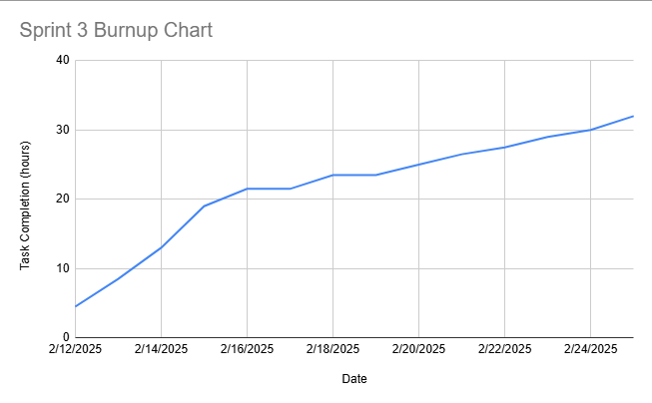

* **Expected time as top line**
* Set dates to update burnup chart
* Questionable why it started above 0
* Take note of flat lines